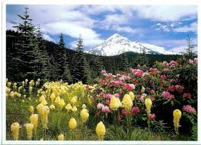
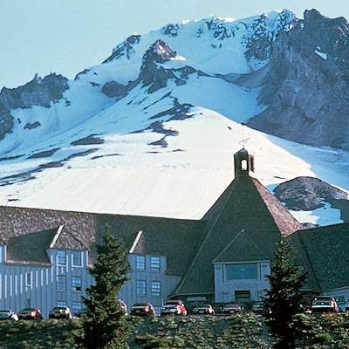

ANNOUNCING . . .
NW Trek’s 10th Anniversary Rally!

Dates: August 18-20, 2014, Mon. thru Wed.
Location: Mt. Hood Village RV Resort,
65000 East Hwy. 26, Welches, OR 97067
Check out their Website!

Wagonmasters: Rodger & Colleen Wright: twocats-trekn@hotmail.com
Ed & Jeanette Block: ed.jnet@earthlink.net
Itinerary: Attendees: Watch for a Rally Update/Map email in late July –
also posted on our club Website, www.nwtfc.com under Rallies.

Day 1: Check-in by 4 pm: A festive happy hour/potluck (hearty hors d’oeuvres), followed by our 10th Anniversary celebration: presentation of our 10 yr. certificate by FMCA Area VP; a special cake, cupcakes, ice cream and punch (compliments of our club). A rare opportunity: Club photo albums (covering 10 years) will be available for reminiscing.
Day 2: Breakfast (Dragonfly Café & Bakery) served at clubhouse, followed by Brazel’s Performance RV tech talk, w/Q&A time, a club business/activity update and door prize drawings! You have all afternoon & evening for yourselves . . . plenty of brochures & restaurant suggestions will be available!
Day 3: Another fine breakfast at the clubhouse; carpool as needed to Mt. Hood’s historic Timberline Lodge; guided, 45 min. group tours of the lodge at 11, 1 & 2pm, ‘Miracle Mile’ ski lift is an option. All will be expected in the lodge’s private, Raven Room at 5 pm for happy hour w/appetizer platter provided. Our pre-ordered dinners will be served immediately afterward.
Day 4: Break camp by 11 a.m. *You will want to be ‘outa there’ before The Hood to Coast race featuring over 12,500 runners and 3,600 volunteers descend on the Mt. Hood area late Thursday, early Friday!

Rally Fee and Campsite Reservations: 40 full hookup, 30/50 amp sites are being held for our rally, including the clubhouse’s spacious Evergreen Room & facilities. After Club Treasurer’s confirmation of rally fee payment, attendees will be advised to make their campsite reservations. Resort Office: Ph. #: (503) 622-4011 or (800) 255-3069. Mention NW Trek Fun Club & wagon master, Rodger Wright, to receive the rally discount (3 nights for $123.24).

Rally Fee covers: (2) T-shirts; Tuesday’s & Wednesday’s breakfasts; Timberline happy hour appetizers, dinners & desserts for 2. Deadline for a Rally Fee refund is Aug. 1 (if there are any people on a Waiting List, a reimbursement may be possible closer to rally time).

T-shirt Details: 10th Anniversary Rally, ‘Dame NW mural’ T-shirts (received artist’s permission to use his artwork for this 1-time order to celebrate NWTFC’s 10th Anniversary). They will be provided at the rally – no mailings.

Breakfasts: Tuesday: Biscuits & gravy, scrambled eggs & country potatoes. Wednesday: French toast stuffed with cream cheese & blue berries; bacon or sausage. Juices will also be provided at breakfast.

Meal at Timberline Lodge: (No host beer & wine available at happy hour). Appetizer: Assorted canapés (smoked salmon on cucumber; Oregon bay shrimp mousse on crostini, sun-dried tomato mouse grilled flat bread roulade. Dinner: includes organic green salad AND chef’s selection of 3 additional salads. Choice of ONE of the following: Hazelnut smoked Prime Rib – slow roasted natural beef, rosemary scented au jus, served with Hood River apple horseradish cream. NW Cedar Plank Salmon, served with Huckleberry Beurre Blanc. Meal includes chef’s selection of rice or potato, seasonal vegetable & Artisan rolls; Pastry Chef’s Dessert selection, gourmet coffee & teas. (All food costs include 19.5% gratuity)

From the Timberline Website: "Perhaps the ultimate compliment to Executive Chef Jason Stoller Smith's talents came in the summer of 2010 when he was invited to the White House. He was asked to represent the cuisine of the Pacific Northwest for a Congressional Picnic personally hosted by President and Mrs. Barack Obama for 2000 guests and members of the United States Congress."
Sub-Total: $202.00 Rally Fee Cost for 2 people (including 3-days campsite) $325.00

Optional Expenses: 2nd day activities or meals; Ski lift ride up the “Magic Mile” (runs 7:30-4pm) $15 per person; Timberline Lodge --No Host bar ($) beer & ($) wine at Happy Hour; Breakfast available Thursday at the resort’s on-site, Dragonfly Café & Bakery – opens 8 a.m.

Rally fee of $ 202.00 (U.S. $) Your check to ‘NW Trek Fun Club’, must be received by our club treasurer by the deadline of June 30th (to allow time to custom order T-shirts.)

Mail to: Colleen Wright, NWTFC, 10575 S.W. Citation Dr., Beaverton, OR 97008

*Must submit Rally Questionnaire with rally fee (T-shirt sizes, dinner entrée choices, etc.) Questions? Call (503) 579-0823

Location: 104 mi – about 2 hrs from Redmond, OR (FMCA Convention 8/13--16)
76.5 miles – about 1-1/2 hrs from Salem, Oregon
42.2 miles – about 1 hr. from Portland, Oregon.
FUN and adventure can be found within minutes of Mt. Hood Village RV Resort. A 27-hole golf course, more than 700 groomed hiking trails, rock climbing, bird watching, mountain biking, miniature golf, fishing, lakes and streams to explore, and the Alpine Slide are just a few of the summertime activities in Mt. Hood National Forest. Historic Timberline Lodge is the only U.S. location that offers year-round skiing and snowboarding. Dine at the lodge’s world class restaurant, run by a first class chef.
. . . . . . . . . . . . . . . . . . . . . . . . . . . . . . . . . . . . . . . . . . . . . . . . . . . . . . . . . . . . . . . . . . . . . . . .
Questionnaire (include w/pymt of rally fee) ________________________________________
Names of Rally Attendees/Member

- Will you be arriving a day early (Sun.) to Mt. Hood Village Resort RV Park? YES____ NO______
- Will you be going on the free tour of Timberline Lodge on Wednesday? YES______ NO ______
- Will you need transportation to Timberline Lodge? YES____ NO _____
- What dinner entrée do you want? Place a number beside your choice:
a. Northwest Cedar Planked Salmon #_______
b. Hazelnut Smoked Prime Rib of Beef #_______
5. What size T-shirt do you want? Small to 3X (Hanes, short sleeve, Beefy T, 100% cotton, color:
natural) a. Size_______
b. Size_______

